***NATIONAL AI DAY***

**This National ‘Ai’ Day, celebrated on April 26, you’ll get to learn about the meaning behind this Chinese and Japanese word. ‘Ai’ means ‘adoration,’ ‘affection,’ or ‘love.’ The word is used almost exclusively as a female name in Japan, but boys are sometimes given it in Chinese too. Notable figures such as Ai Wei Wei, Ai Sugiyama, and Ai Otsuka share this name, and dozens of videogames, cartoons and fantasy characters with the name appear across Japanese and Chinese media. It’s pronounced similar to the word ‘eye’ in both cultures, but the kanji (Japanese) inscriptions differ from the hanzi (Chinese) characters.**



**HISTORY OF NATIONAL AI DAY**

**Ai Wei Wei is a Chinese activist and artist known in the East and West for his creative works. Because he is known for being politically outspoken and the divisive nature of his art, Wei Wei is persecuted by repressive government authorities. In 2005 he began using social media as a tool for social commentary. In 2009 his blog website was shut down. He moved to Twitter and continued online journaling from there, much to the dismay of the Chinese government. This led to Wei Wei’s house arrest in 2010 and subsequent arrest in 2011 at Beijing airport. He was then jailed for unspecified crimes but got released after serving three months in prison. Ai Wei Wei now lives in exile in Portugal and remains a critic of the Chinese Communist Party**.

**Japanese tennis star Ai Sugiyama held the record for male and female players in 62 consecutive Grand Slam main-draw appearances until 2015 when Roger Federer surpassed her. Sugiyama began playing tennis at 17, debuting at Wimbledon against world number 30 Gigi Fernandez. Throughout her nearly 20-year career, she rose to the world number one ranking in the WTA, winning the U.S. Open in 1999 and 2000, the French Open in 2003, and Wimbledon in 2003. She retired in 2009 after the Pan-Pacific Open and now teaches aspiring tennis players in Japan.**

**Ai Otsuka is a Japanese singer-songwriter famous for her song “Sakuranbo,” released in 2003. The 39-year-old musician was a child prodigy who began playing the piano at age four and writing songs in her teens. Trained as nursery teachers, Otsuka and her former classmate Mami Nishida started to record and upload music online in the early 2000s, sending demo tapes to studios with little success. In 2003 the popularity of “Sakuranbo” got Otsuka signed to Avex Trax, one of Japan’s biggest record labels. In 2004 she released her debut album “Love Punch,” which peaked at number three on Japanese music charts and sold nearly 200,000 copies in its first week**.

**NATIONAL AI DAY ACTIVITIES -**

1. **Read Ai Qing’s poetry**

Ai Qing, Wei Wei’s father, was regarded as one of China’s finest poets. Read his works on National ‘Ai’ Day.

1. **Paint some ‘kanji’**

Learn how to paint the name ‘Ai’ in Japanese. Not only will you create a piece of art, but, in one stroke, you’ll give tribute .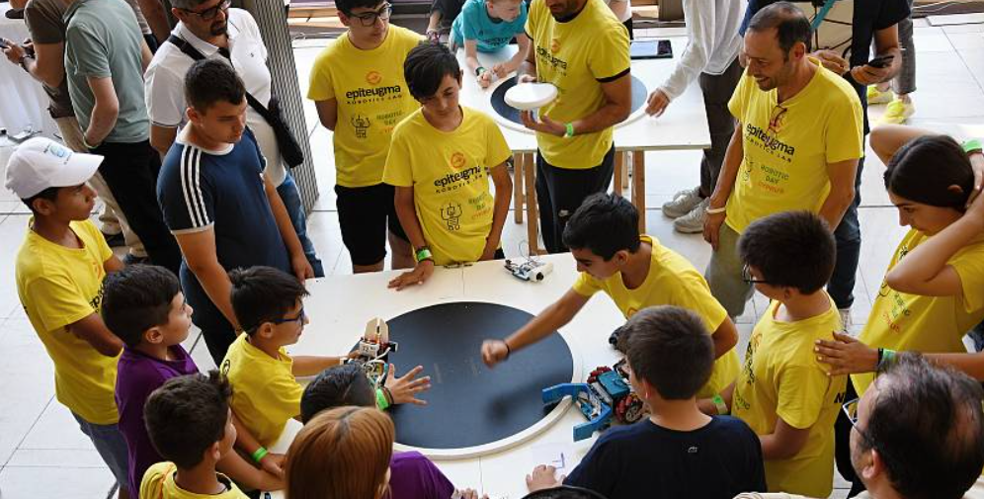



1. **What’s in a name?**

**Chinese activist and artist Ai Wei Wei has an asteroid named after him.**

1. **A master of blackjack**

**Ai Wei Wei is considered a professional blackjack player.**

**WHY WE LOVE NATIONAL AI DAY**

1. **Short and sweet**

Ai is a short and sweet name. It’s easy to remember and even easier to spell.

1. **Cultural fluidity**

Not often do names work so seamlessly across different cultures, down to the same connotations. But ‘Ai’ is embraced by both the Japanese and Chinese.

1. **It means love**

‘Ai’ means ‘love.’ The name embodies the spirit of affection.

NATIONAL AI DAY DATES -

| **Year** | **Date** | **Day** |
| --- | --- | --- |
| 2024 | April 26 | Friday |
| 2025 | April 26 | Saturday |
| 2026 | April 26 | Sunday |
| 2027 | April 26 | Monday |
| 2028 | April 26 | Wednesday |

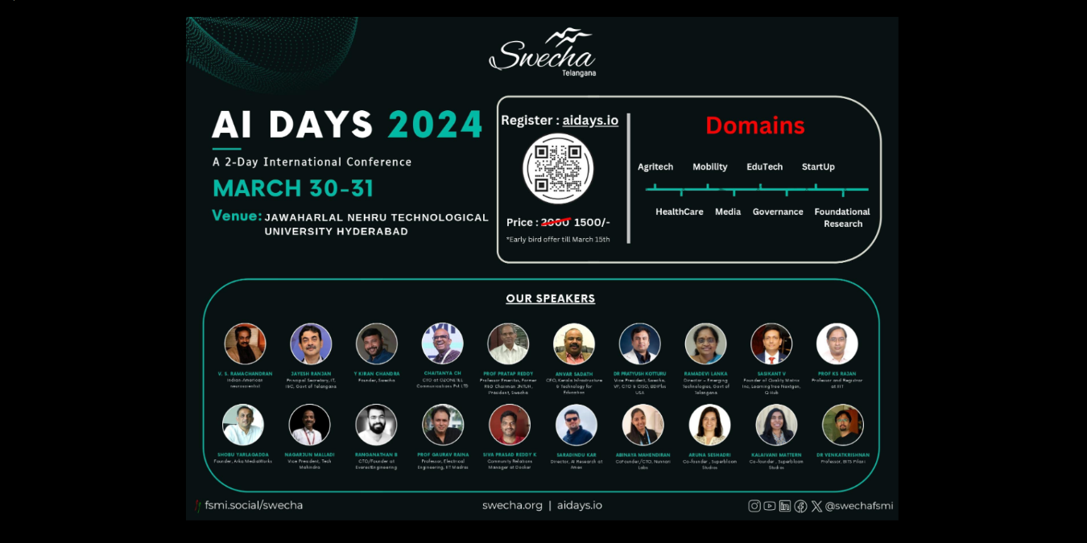

[International Chernobyl Disaster Remembrance Day](https://nationaltoday.com/international-chernobyl-disaster-remembrance-day/)

[National Ai Day](https://nationaltoday.com/national-ai-day/)

[[](https://nationaltoday.com/arbor-day/)](https://nationaltoday.com/arbor-day/)

[National Arbor Day](https://nationaltoday.com/arbor-day/)

[[](https://nationaltoday.com/national-dissertation-day/)](https://nationaltoday.com/national-dissertation-day/)

[National Dissertation Day](https://nationaltoday.com/national-dissertation-day/)

[National Gabriel Day](https://nationaltoday.com/national-gabriel-day/)

[National Garage Day](https://nationaltoday.com/national-garage-day/)

[[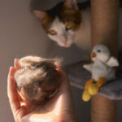](https://nationaltoday.com/national-hairball-awareness-day/)](https://nationaltoday.com/national-hairball-awareness-day/)

[National Hairball Awareness Day](https://nationaltoday.com/national-hairball-awareness-day/)

[[](https://nationaltoday.com/national-help-horse-day/)](https://nationaltoday.com/national-help-horse-day/)

[National Help A Horse Day](https://nationaltoday.com/national-help-horse-day/)

[National Jason Day](https://nationaltoday.com/national-jason-day/)

[[](https://nationaltoday.com/national-kids-pets-day/)](https://nationaltoday.com/national-kids-pets-day/)

[National Kids and Pets Day](https://nationaltoday.com/national-kids-pets-day/)

[National No Makeup Day](https://nationaltoday.com/national-no-makeup-day/)

[[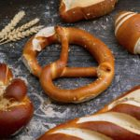](https://nationaltoday.com/national-pretzel-day/)](https://nationaltoday.com/national-pretzel-day/)

[National Pretzel Day](https://nationaltoday.com/national-pretzel-day/)

[National South Dakota Day](https://nationaltoday.com/national-south-dakota-day/)

[National Static Cling Day](https://nationaltoday.com/national-static-cling-day/)

[Remember Your First Kiss Day](https://nationaltoday.com/remember-your-first-kiss-day/)

[[](https://nationaltoday.com/richter-scale-day/)](https://nationaltoday.com/richter-scale-day/)

[Richter Scale Day](https://nationaltoday.com/richter-scale-day/)

[Secretaries' Day (Colombia)](https://nationaltoday.com/secretaries-day-colombia/)

[[](https://nationaltoday.com/stop-food-waste-day/)](https://nationaltoday.com/stop-food-waste-day/)

[Stop Food Waste Day](https://nationaltoday.com/stop-food-waste-day/)

[Undiagnosed Children's Awareness Day](https://nationaltoday.com/undiagnosed-childrens-awareness-day/)

[World Burlesque Day](https://nationaltoday.com/world-burlesque-day/)

[World Intellectual Property Day](https://nationaltoday.com/world-intellectual-property-day/)

[World Women’s Wellness Day](https://nationaltoday.com/world-womens-wellness-day/)

[View all April holidays](https://nationaltoday.com/april-holidays/)

LIVE POLL

How statisfied are you with your local government?

[Vote Now](https://app.wisevoter.com/survey/f9508df6-0b76-45a6-8e5f-7b9363fa2f0d/?url=https://nationaltoday.com/national-ai-day/" \t "_blank)

**HOLIDAYS STRAIGHT TO YOUR INBOX**

Every day is a holiday!  
Receive fresh holidays directly to your inbox.

[Log In With Google](https://nationaltoday.com/?google_redirect&)

* 6,428Days celebrated
* 19,284Ways to celebrate
* 1,000,000+Happy users

ABOUT US

* [Our Mission](https://nationaltoday.com/our-mission/)
* [Our Story](https://nationaltoday.com/our-story/)

RESOURCES

* [For Businesses](https://nationaltoday.com/business/)
* [For Journalists](https://nationaltoday.com/for-journalists/)
* [For Brands](https://nationaltoday.com/for-brands/)
* [For Influencers](https://nationaltoday.com/for-influencers/)
* [FAQs](https://nationaltoday.com/holiday-questions/)
* [News](https://nationaltoday.com/news/)

CONTACT US

* [Submit a Holiday](https://nationaltoday.com/create-holiday/)
* [Promote an Event](https://nationaltoday.com/promote-an-event/)
* [Work With Us](https://nationaltoday.com/work-with-us/)
* [Submit an Error](https://nationaltoday.com/submit-an-error/)

OUR SERVICES

* [Create A Holiday](https://nationaltoday.com/business/create-a-holiday/)
* [Sponsor A Holiday](https://nationaltoday.com/business/sponsor-a-holiday/)
* [Data Licensing](https://nationaltoday.com/business/data-licensing/)

MONTHS

* [January](https://nationaltoday.com/january-holidays/)
* [February](https://nationaltoday.com/february-holidays/)
* [March](https://nationaltoday.com/march-holidays/)
* [April](https://nationaltoday.com/april-holidays/)
* [May](https://nationaltoday.com/may-holidays/)
* [June](https://nationaltoday.com/june-holidays/)
* [July](https://nationaltoday.com/july-holidays/)
* [August](https://nationaltoday.com/august-holidays/)
* [September](https://nationaltoday.com/september-holidays/)
* [October](https://nationaltoday.com/october-holidays/)
* [November](https://nationaltoday.com/november-holidays/)
* [December](https://nationaltoday.com/december-holidays/)

UPCOMING

* [Today](https://nationaltoday.com/today/)
* [Tomorrow](https://nationaltoday.com/tomorrow/)
* [Monday](https://nationaltoday.com/is-monday-a-holiday/)

ALL MONTHS

* [National Today Calendar](https://nationaltoday.com/national-today-calendar/)

GIFTS

* [Reviews and Gift Guides](https://nationaltoday.com/gifts/)

BLOG

* [Blog Home](https://nationaltoday.com/blog/)

SHOPPING REVIEWS

* [Baby](https://nationaltoday.com/reviews/baby/)
* [Car](https://nationaltoday.com/reviews/car/)
* [Children](https://nationaltoday.com/reviews/children/)
* [Health & Fitness](https://nationaltoday.com/reviews/health-fitness/)
* [Home & Garden](https://nationaltoday.com/reviews/home-garden/)
* [Kitchen](https://nationaltoday.com/reviews/kitchen/)
* [Pets](https://nationaltoday.com/reviews/pets/)
* [Sleep](https://nationaltoday.com/reviews/sleep/)
* [Tech](https://nationaltoday.com/reviews/tech/)
* [Travel](https://nationaltoday.com/reviews/travel/)

GIFT GUIDES

* [By Age](https://nationaltoday.com/gift/age/)
* [By Interest](https://nationaltoday.com/gift/interest/)
* [By Occasion](https://nationaltoday.com/gift/by-occasion/)
* [By Price](https://nationaltoday.com/gift/by-price/)
* [By Recipient](https://nationaltoday.com/gift/by-recipient/)

POPULAR HOLIDAYS

* [National Girlfriend Day](https://nationaltoday.com/national-girlfriend-day/)
* [Day of the Dead](https://nationaltoday.com/day-of-the-dead/)
* [National Boyfriend Day](https://nationaltoday.com/national-boyfriend-day/)
* [National Sons Day](https://nationaltoday.com/national-sons-day/)
* [Mexican Independence Day](https://nationaltoday.com/mexican-independence-day/)
* [Pride Month](https://nationaltoday.com/pride-month/)
* [National Best Friends Day](https://nationaltoday.com/national-best-friends-day/)
* [National Daughter Day](https://nationaltoday.com/national-daughter-day/)
* [World Bicycle Day](https://nationaltoday.com/world-bicycle-day/)
* [National Dog Day](https://nationaltoday.com/national-dog-day/)

About National Today

We keep track of fun holidays and special moments on the cultural calendar — giving you exciting activities, deals, local events, brand promotions, and other exciting ways to celebrate.

Follow us on

Copyright © 2017–2024 by National Today. [Privacy policy](https://nationaltoday.com/privacy-policy/)